RIGA'S REPORT ON THE EUROPEAN UNIONS STRATEGY FOR THE BALTIC SEA REGION, PROGRESS IN IMPLEMENTING
15-17 JUNE,
RIGA, JURMALA
LATVIA

Report on participation in the implementation of the Baltic Sea strategy of citizens and civil society organizations

2015

Introduction
Discussions on implementation of the European Unions Strategy for the Baltic Sea Region (EUSBSR) and renewed Action Plan is a vital process for the civil society of the region already for as many years strategy exist. Therefore Civic Alliance Latvia, in co-operation with the Ministry of foreign affairs and the secretariat of the Latvia’s presidency in EU 2015 organized event Riga's report on the EU Strategy for the Baltic Sea region, progress in implementing.

Other, vital reason for preparation of this report is the fact, that among horizontal actions, one of four horizontal actions, in the EUSBSR among Climate adaptation, Neighbours and Spatial planning as equal is Involve. Taking into consideration, that there is some infrastructure in place, meaning Horizontal actions co-ordinator (HAC) and the fact, that document states that HAC is obliged to focus on activities, relevant at macro-regional level, involving stakeholders from different countries in the Baltic Sea region, civil society organizations are interpreting this statement as window of opportunity for the engagement of citizens initiatives. Horizontal action is stating necessity to involve with different stakeholders while implementing multi level governance as well as highlights role of the civil society in the implementation of different actions in the region.

Project is prepared by the Civic Alliance – Latvia, the largest advocacy umbrella organization in Latvia and it had two substantial aims: 1)ensure participation of civil society representatives in the VI Annual Forum of the EU Strategy for the Baltic Sea Region „ACHIEVING E-QUALITY by CONNECTING REGION(S) with themes: e-culture, e-health, e-science, energy efficiency, spatial planning; 2)to ensure exchange of experiences from the eight countries about the citizen engagement in the implementation of the EUSBSR by providing space for learning and sharing best practices with our partners of other regions and among participants from all countries, taking part in the Project.

Initiative lasted for three days and its programme was adopted to the official programme, leaving space for civil society organizations space to discuss status of civil dialogue, access to information and other related topics. One of the important tasks of the event was also to organize experience exchange outside of Riga and Jurmala, providing possibilities to the regional partners to be engaged. One day by participants of the event was spent in Talsi, where the local municipality was hosting participants, the local NGO support centre was providing extensive insight in the work they deliver in the Kurzemes district, as well as guests from the Black Sea region and Danube region provided participants with extensive insights of the work of the civil society networks of the regions.

Event gathered together sixteen people from eight countries around the Baltic Sea region and one representative from the Black Sea region and one from the Danubs region. The most importantly it is to notice, that group was not only civil society organizations representatives, but in the group, there were representatives for academic sector and public sector. As it is known, sub regional strategies are being designed to make comprehensive efforts towards cohesion of the region and improving speed of the development in the countries of the regions using co-operation among different sectors and levels, therefore it was great opportunity to learn about both Black Seas and Danubs way of work engaging citizens and civil society in improving regions wellbeing as well as hearing views from representatives in the academic and public sector.

Engagement of the civil society organizations and citizens is not only the task of the regional strategies, there are hierarchically higher documents, stating necessity to ensure citizens engaging in the policies of EU. Therefore, in this context we cans say, that there is clear framework for activities, ensuring civic dialogue.

Documents - directly influencing the citizen participation in EU and Pan European region - Baltic Sea:
- The Lisbon Treaty ((Articles 11(1) and 11(2)): 1)The institutions shall, by appropriate means, give citizens and representative associations the opportunity to make known and publicly exchange their views in all areas of Union action. 2)The institutions shall maintain an open, transparent and regular dialogue with representative associations and civil society.
- The EU Strategy for the Baltic Sea region: Connecting people in the region: The objectives of the Strategy will be achieved by improving cooperation between the actors involved. Therefore, in almost all policy areas and horizontal actions, one of the effects of the Strategy will be to better connect the people in the region, either by setting-up new networks and new platforms of cooperation, or by strengthening the existing ones. Connecting the region also includes improved access to communications networks and the internet as basis for seamless flow of information and closer and more instantaneous cooperation and exchange. And horizontal action (HA) Involve- invited to focus on activities relevant at macro-regional level, involving stakeholders from different countries in the Baltic Sea region.
This report is not aiming to replace statements or declarations by other organizations or networks such as the final statement of the 13th Baltic Sea NGO FORUM “A Smart Civil Society– for the best of the Baltic Sea Region (BSR)”, taking place just shortly before current event from 10th to11th of June 2015 in Tallin, Estonia, neither this report aims to pretend, that it is an eco of whole civil society in the Baltic Sea region.

With this report we, participants of this event want to ensure that progress on citizen engagement is taken as a serious topic for the implementation of the EU Strategy for the Baltic Sea Region in the future. We provide our suggestion for improved dialogue and practical co-operation.

SHOWCASE
SCALE AND INTENSITY OF PARTICIPATION OF CIVIL SOCIETY ORGANIZATIONS
DIFFERENT REGIONS

Stefan August Lütgenau, Foster Europe, Foundation for strong European Regions, presentation about civil dialogue, access to information for civic society/NGO in Danube region.

Consultation phase - formation of an active Civil Society Cluster:
Civil society debate leading to fundamental demands to be taken into consideration and ensuring participation in the implementation of the EUSDR, and those are:
- self-organisation – civil society organizations organize their own consultation process;
- horizontal and vertical participation – civil society representatives are represented in all structural bodies implementing the strategy;
- Formation of an Civil Society Forum as a regular event to hear necessity and needs of the civil society organizations of the region;
- Anchoring key structures in the Action Plan;
- Political and financial support for civil society participation in the EUSDR.

From “Let us in!” to “listen!” to “react!”
- Civil societies access to information (level of priority area) and Annual Forum is a vital instrument for engagement in the implementation of the strategy;
- Participation as European Imperative;
- Opening Spaces for Participation (local actors, Participation Day);
- 1st Participation Day and Eisenstadt Declaration;
- Enforcing the importance of the National hearings;
- 2nd Participation Day took place in Ulm, 2015 (ensured institutionalisation of the participation).
Participation Day ensures: 1) political message by civil society on horizontal/vertical participation; 2)Presentation of Competence/Expertise of CS in the Danube Region; 3)Fair of possibilities, NGOs, projects, actors, challenges etc.; 4) open, participative and interactive formats.The upcoming chairs EU Strategy Danube Region - Slovakia 2016; Hungary -2017. Key challenges for the regions network: 1)making the model of horizontal/vertical participation understood; 2)mobilising active responsible civil society, getting hosting countries on board; 3) funding for the Participation Day and steering group.

Scheme of the participation
model in the EUSDR

Valentin Burada, Civil Society Development Foundation, presentation about civil dialogue, access to information for civic society/NGO in the Black sea region

The Black Sea region is a very complex and diverse region from the perspective of political regimes, level of development of civil society and geopolitics. The political context highly influences the opportunity for civil dialogue and access to information.
The wider Black Sea region includes: new EU member states (Bulgaria and Romania); South Caucasus former soviet states (Armenia, Azerbaijan and Georgia), former Soviet Union states at the Western border of Russia (Moldova and Ukraine); one superpower state (Russia) and one regional power (Turkey). Most of the countries in the region have (frozen or open) conflicts within or close to their borders: Ukraine, Russia, Turkey, Armenia, Azerbaijan, Georgia, Moldova.
In terms of political regimes, there is high range of varieties: relatively stable new democracies (Bulgaria, Romania, Georgia); unstable and fragile democracies (Moldova, Ukraine); countries with significant authoritarian tendencies (Turkey, Armenia); heavy authoritarian regimes (Russia, Azerbaijan). They all share on common pattern: a tendency for political decision makers to operate behind closed doors, covering up for corruption and misappropriation of public funds and keeping citizens and civil society at bay.
In terms of civic dialogue, most countries in the region pretend to be open to citizen participation. More authoritarian regimes (Russia, Azerbaijan) have created institutions and laws which exclude all independent critical civil society while creating a parallel system of loyal civil society (GONGOs) with limited space for operation in areas which are not perceived as threatening to Governments (charity, social, education and recreation). Civic dialogue is fake. In other countries, civic dialogue is most of time an empty vessel: Governments consult with civil society because they are expected to, yet civil society’s proposals are seldom taken into account (Romania, Bulgaria). In countries with recent “revolutionary” events, where former civil society activists are part of the new Governments, there have been direct avenues to influence political decision making (Moldova, Georgia, Ukraine) which, after a while, when the revolutionary enthusiasm is gone and geopolitics come back into place, tend to disappear.
While most of the countries have legislation allowing for access to information and for influencing decision making by civil society, in practice enforcement is poor. In Romania for example, after 15 years from the adoption of the FOIA legislation, enforcement has become more regular, although there is still resistance from public authorities to disclose information. After years of successful litigation in courts, the practice of sharing public information has become more regular, although most of the time public authorities remain rather reactive (providing information on request), rather than opening the access by default.

Inese Siliņa, Kurzeme NGO support centre presentation about civic society in Latvia, regional perspective
Kurzeme NGO Support center: i san Non-govermental organization, it has Public benefiT status and is founded in 1998. Organizations aim is strengthening civic society and its development. It has 46 member organizations and it ensures cooperation with others NGO, municipalities and government.
MAIN ACTIVITIES OF THE CENTER:
- Educational and consultative activities (legal, accounting, project writing, publicity)
- Cooperation and twinning (forums, conferences)
- Gathering information on the NGOs important news and its distribution
- Participating activities of NGOs in policy
- Working with different society groups: adults, youth, children
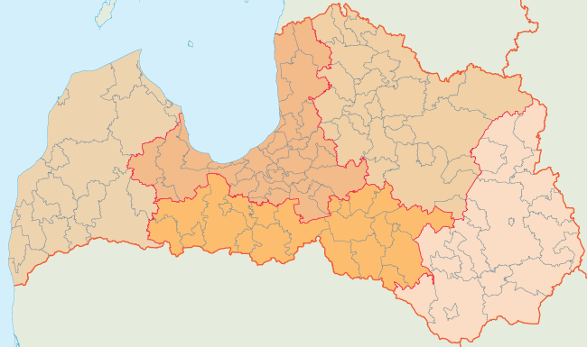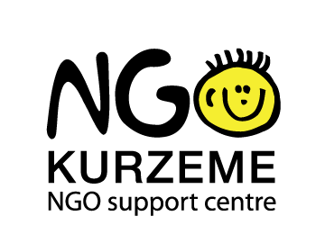
Kurzeme Region
Riga Region
Zemgale Region
Vidzeme Region
Latgale Region
~ 20 000 NGO in Latvia
61%
13%
9%
9%
8%
INFORMATION NETWORKS:
- Regional homepage – www.kurzemesnvo.lv with short section in English;
- Data base of Kurzemes regions CSOs (with contacts);
- Informative NGO e-mail newsletter (around 1000 receivers).
It was useful to learn regional perspective as well as to meet with regional organizations, working in different fields. During the event several new partnerships were established.

Rasma Pipike, Civic Alliance-Latvia presentation about networking in the Baltic sea region and MyVoice for the Baltic sea region initiative
ManaBalss.lv is a public participation platform in Latvia where every citizen of Latvia at least 16 years of age can submit and sign initiatives and e-petitions for any level legislation change. Anyone who has a good idea how to improve existing laws or create new ones can register his/her idea and gather supporters' signatures.
Once an initiative reaches 10 000 signatures, it is officially submitted to the Parliament, where it is processed and included in the Parliament's official agenda. Later it is discussed together with the author and experts, and Parliament makes the final decision - either the idea presented in the initiative becomes a law or not.
All users of ManaBalss.lv are required to authorize through a state-registered online bank. ManaBalss.lv ensures privacy and the security of personal data.
All initiative authors and users of ManaBalss.lv receive technical, legal and communications support, and ManaBalss.lv makes sure all ideas presented to Parliament are processed and heard.
After three years of work ManaBalss.lv has proved itself to be one of the most effective, widespread and popular civic participation projects in Latvia's history. ManaBalss.lv has been recognized as an open government success story all across the globe. It was mentioned by US President Barack Obama during the Open Government Partnership Initiative launching event, it has been featured in publications by New York Times and The Guardian, as well as recognized as “one of the outstanding challengers from Eastern and Central Europe”.
In three years since initiatives launch:
- Over 1 000 000 people (around 35% of Latvia's population) have visited ManaBalss.lv
- 14 initiatives have gathered more than 10 000 votes, making their way to the Parliament.
- 7 ideas have become important amendments in national level laws.
- More than 100 000 people have chosen to sign at least one initiative, in total more than 300 000 signatures have been collected.

Proposal for the citizen engagement in the regions development process is to create pan European consultation mechanism with civil society and citizens for the EU Strategy for the Baltic Sea region. This idea is being presented and accepted by the Baltic Sea NGO network in its final declarations in 2013 and 2014.

RECOMMENDATIONS BY PARTICIPANTS TO IMPROVE CIVIL DIALOGUE, ACCESS TO INFORMATION FOR CIVIC SOCIETY/NGO, PARTICIPATION IN THE IMPLEMENTATION OF THE EU STRATEGY FOR THE BALTIC SEA STRATEGY

Recommendations below has been worked out by participants of this event with clear aim to set a vision for civil dialogue in the Baltic Sea region by taking concrete action towards sustainable, inclusive and participative dialogue at different levels (relation between civil society organizations and other stakeholders) and providing showcase of good practices and suggestions from the CSOs around the Baltic Sea and other regions, undergoing a like or similar actions to ensure intensified development of concrete region.

1. To improve civil dialogue suggestions are as follows:
- Understanding between sectors, creating more inter-sectoral initiatives;
- The sectors have responsibility to give insight to civil society;
- Recognition of civil society as a diverse sector with a multitude of sectors;
- Transfer of good practises horizontally;
- C-D on multilevel (single level/national/regional level)

2. To ensure access to information for the citizens and civil society organizations suggestions are as follows:
EUBSRS requires interactive WEB platform, providing information on the following topics: inclusion/participation; News; Social network; Events; Public info; List or data base of People to people initiative; Stakeholder to stakeholder. It would be reasonable to create Baltic Sea hub TV (media info). By creating Baltic Sea Day (in August, to raise awareness of the regions development priorities).Information would be relevant from the different points of views: 1) Possibility to check sources of the info, you hope that governmental level will provide useful and open information, authorities would be aware to explain the choice and impact of decisions, all stakeholders would be informed about important events, info access would be much quicker/speedy, EU institutions would have easier and human closer (understandable) co-operation with its citizens.
- To ensure participation in the implementation of the EUBSRS of civil society organizations:
- Political will, multilevel governance (to go from politicians to civil society) practically and realistically;
- CSOs shall explain and provide actively information to policy makers and citizens (show, create ideas, projects, what works);
- Better communicating impact for daily day life through media
- There should be some institutionalized agreement between CSOs and public sector about the implementation and participation of the CSOs and citizens in the processes affecting regions development.
- Schools should have a common programme for raising interest of students in civic participation, providing students with information on activities and possibilities to get engaged in the processes of the regions development.
- Human rights education: bring understanding for trying to achieve situation, were everybody’s human rights in the region are respected.
- Exchange programms for schools on all levels should be created and promoted to ensure more intensified people to people activities.

Measures financed by the Latvian government. Activity was implemented in close co-operation with the following organizations:
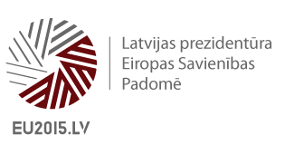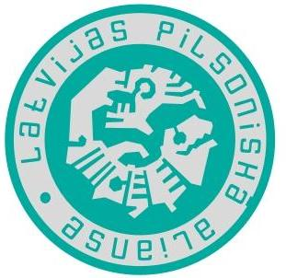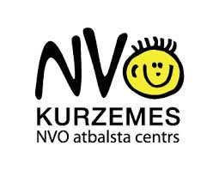

Attachment nr. 1.
List of participants.
No.  p.k. | Name, Surname | Organization | Country
1. | Genute Gedviliene | Vytautas Magnus University | Lithuania
2. | Vilija Lukosuniene | Lithuanian Association of Adult Education | Lithuania
3. | Valentin Burada | Civic Innovation Fund | Rumania
4. | Sonja Haugaard Christensen | Danish Russian Association Aarhus | Denmark
5. | Kirsten Gjaldbæk | Association Denmark-Latvia | Denmark
6. | Magda Leszczyna-Rzucidło | Baltic Institute for Regional and European Concern BISER | Poland
7. | Izabela Borucinska-Dereszkiewicz | Gdansk University of Technology | Poland
8. | Stefan August Lütgenau | Foster Europe, Foundation for strong European Regions | Austria
9. | Jörg Mirtl | Priority Area 10 of the EU Strategy for the Danube Region | Austria
10. | Ludmila Morozova | Karelian Republican Council of the All-Russian Society for Nature Protection | Karelia
11. | Vladimir Lukanin | Karelian Republican Council of the All-Russian Society for Nature Protection | Karelia
12. | Vassili Golikov | SSCW | Estonia
13. | Merle Haruoja | Estonian Institute of Human Right | Estonia
14. | Rebecka Lettevall | Centre for Baltic and East European Studies | Sweden
15. | Emelie Weski | Secretary General Norden Association Youth | Sweden
16. | Rasma Pīpiķe | Civic Alliance-Latvia | Latvia
17. | Anita Īvāne | Civic Alliance-Latvia | Latvia
18. | Kristīne Zonberga | Civic Alliance-Latvia | Latvia

